**Lambda and streams**

**Exercise 1**

Create a new project in your corresponding GitHub-folder (according to the instructions in the document on Canvas “How to create a project in IntelliJ) and add a class **PrimeCalculator** (in a package called *model*)according to the UML-diagram below:

Don’t forget to commit and push regularly!

Implement the methods below without using any plain iteration(!). We advise you to do this in the following sequence:

* The method *getListOfAllNumbersUntil* creates a list of integers starting from the start-value until the end-value (inclusive). Tip: use the InStream-class which has an interesting static method called “range(start, end)”. Be careful! This method generates a list of integers (the end-value exclusive) as an InStream-object. To make a list of integers, you need to use the method “boxed()” and the “toList()” method
* The method *isPrime* has to implement the prime logic: if a number is a prime, this method returns true. In all other cases this method returns false. This method makes use of the previous method…
* The method *getAllPrimesUntil* generates all prime numbers starting from 0 until the value of the number-value (inclusive). This method makes use of the previous methods…

Write tests with 100% coverage for this class. Take into account in your tests that “1” is not a prime…

Now create the web application. In **index.html** you can enter a number, e.g. 80 like in the example below:

After submitting this number your web application has to take you to a page where all the primes are shown until the number entered in the index-page (inclusive):

In order to generate all prime numbers, make optimal use of the methods in the PrimeCalculator-class.

**Exercise 2**

Create a new project in your corresponding GitHub-folder (according to the instructions in the document on Canvas “How to create a project in IntelliJ) and add the following classes (in a package called model) according to the UML-diagram below:

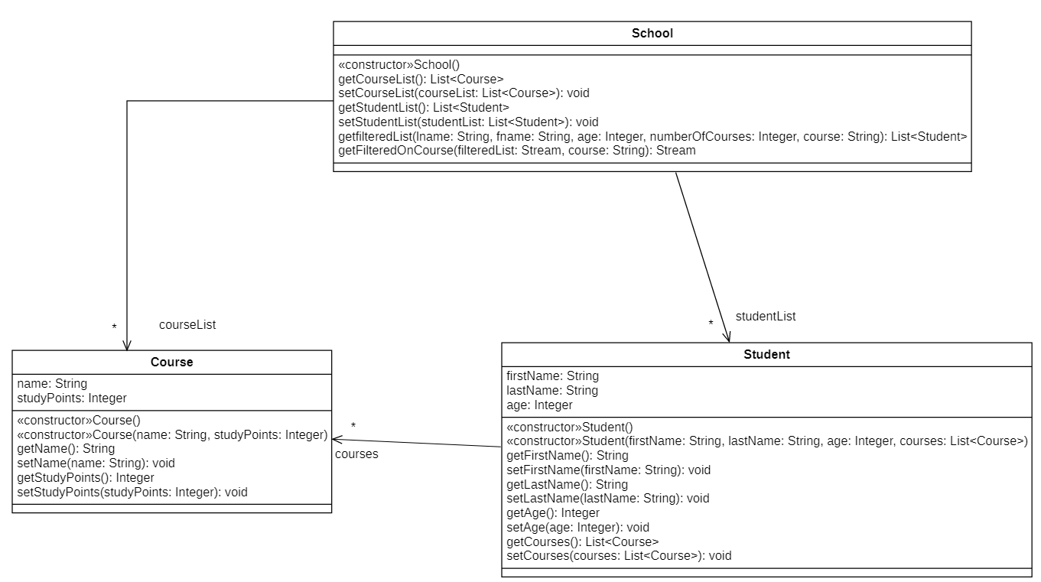

Implement the methods below without using any plain interation.

* In the constructor School() fill the courseList and studentList with the following objects:
* Course programmerI = **new** Course(**"Programmer I"**, 5);  
  Course sqlDatabases = **new** Course(**"SQL Databases"**, 3);  
  Course linux = **new** Course(**"Linux"**, 8);  
  **courseList** = Arrays.*asList*(programmerI, sqlDatabases, linux);  
  **studentList** = Arrays.*asList*(  
   **new** Student(**"Amber"**, **"Akkermans"**, 21, Arrays.*asList*(programmerI, sqlDatabases, linux)),  
   **new** Student(**"Bert"**, **"Bergmans"**, 18, Arrays.*asList*(linux)),  
   **new** Student(**"Carly"**, **"Coopman"**, 25, Arrays.*asList*(programmerI, linux)),  
   **new** Student(**"Dirk"**, **"Dieltjens"**, 19, Arrays.*asList*(programmerI, sqlDatabases)),  
   **new** Student(**"Erik"**, **"Eyken"**, 17, Arrays.*asList*(programmerI, sqlDatabases, linux)),  
   **new** Student(**"Fré"**, **"Frederickx"**, 23, Arrays.*asList*(linux)),  
   **new** Student(**"Gust"**, **"Grevers"**, 20, Arrays.*asList*(sqlDatabases, linux)),  
   **new** Student(**"Hans"**, **"Hooimans"**, 22, Arrays.*asList*(programmerI, sqlDatabases, linux)),  
   **new** Student(**"Isis"**, **"Ilsen"**, 19, Arrays.*asList*(sqlDatabases, linux)),  
   **new** Student(**"Joris"**, **"Jonkers"**, 25, Arrays.*asList*(programmerI, linux)),  
   **new** Student(**"Kim"**, **"Keuppens"**, 31, Arrays.*asList*(programmerI)),  
   **new** Student(**"Laura"**, **"Liekens"**, 21, Arrays.*asList*(sqlDatabases)),  
   **new** Student(**"Merel"**, **"Meulemans"**, 18, Arrays.*asList*(programmerI, sqlDatabases, linux)),  
   **new** Student(**"Nele"**, **"Nauwelaers"**, 19, Arrays.*asList*(linux)),  
   **new** Student(**"Oscar"**, **"Oppens"**, 18, Arrays.*asList*(programmerI, sqlDatabases, linux)),  
   **new** Student(**"Pieter"**, **"Peters"**, 21, Arrays.*asList*(programmerI, sqlDatabases, linux)),  
   **new** Student(**"Quinten"**, **"Qwards"**, 22, Arrays.*asList*(sqlDatabases, linux)),  
   **new** Student(**"Rik"**, **"Rubens"**, 20, Arrays.*asList*(programmerI, sqlDatabases)),  
   **new** Student(**"Stef"**, **"Stekker"**, 20, Arrays.*asList*(programmerI)),  
   **new** Student(**"Toon"**, **"Timmers"**, 21, Arrays.*asList*(programmerI, linux)),  
   **new** Student(**"Ursula"**, **"Uyterhoeven"**, 22, Arrays.*asList*(programmerI, sqlDatabases, linux)),  
   **new** Student(**"Viktor"**, **"Van der Veken"**, 20, Arrays.*asList*(programmerI, linux)),  
   **new** Student(**"Wim"**, **"Winkers"**, 21, Arrays.*asList*(programmerI)),  
   **new** Student(**"Xanty"**, **"Xanders"**, 19, Arrays.*asList*(programmerI, sqlDatabases, linux)),  
   **new** Student(**"Yael"**, **"Ysebaert"**, 18, Arrays.*asList*(linux)),  
   **new** Student(**"Zuster"**, **"Zulma"**, 22, Arrays.*asList*(sqlDatabases, linux)));
* The method *getfilteredList(String lname, String fname, Integer age, Integer numberOfCourses, String course)* returns a list of students that are filtered according to the arguments that are given. This method has to call the method *getFilteredOnCourse(Stream<Student> filteredList, String course)* only if a choice is made for a course. This method returns the students with the course that is given in the parameter.

Write tests with 100% coverage for all classes in the UML diagram.

The MainController has 1 private attribute *school* of the class School. When starting the application, the MainController has to instantiate the attribute causing the *studentList* and *courseList* of the object *school* to be filled. create the web application.

Now create the web application and start with the page **index.html**:

After filling in the desired criteria, the web application should show the students that meet alle the criteria.

Hereafter you see some examples to check whether your implementation is correct:

**Example 1**

Students with lastname contains “r” and firstname contains “a”:

**Example 2:**

Students older than 20 years and more than 2 courses:

**Example 3:**

Students with Lastname containing a “u” and following the SQL Databases course:

